

|  |
| --- |
| *BS Cyber Security Department AU* |

|  |  |
| --- | --- |
| **Registration ID** | **233026** |
| **Submitted By** | **Muhammad Sohaib Rafiq** |
| **Submitted To** | **Iram Fatima Hashmi** |
| **Date of Submission** | **05/09/2024** |
| **Lab NO.** | **8** |
| **Subject** | **NS LAB** |

**Download and install:**

**a. By using Kali Linux**

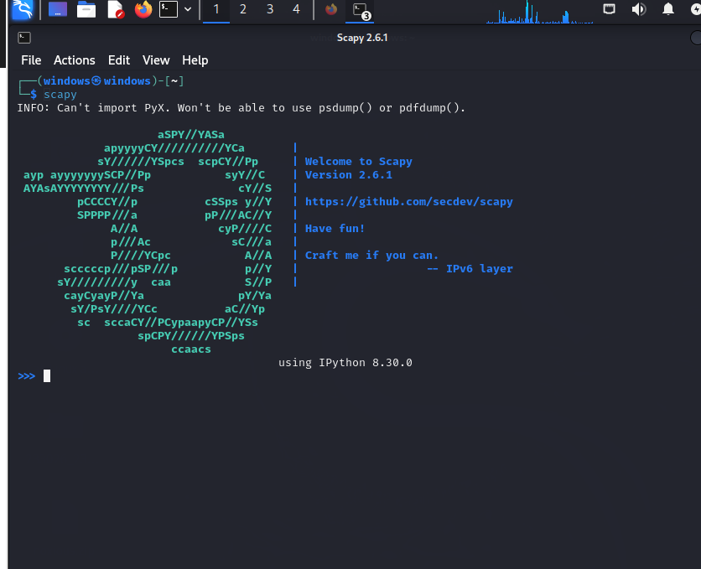

**Sending Packets**

**·Simple Packet Crafting:**

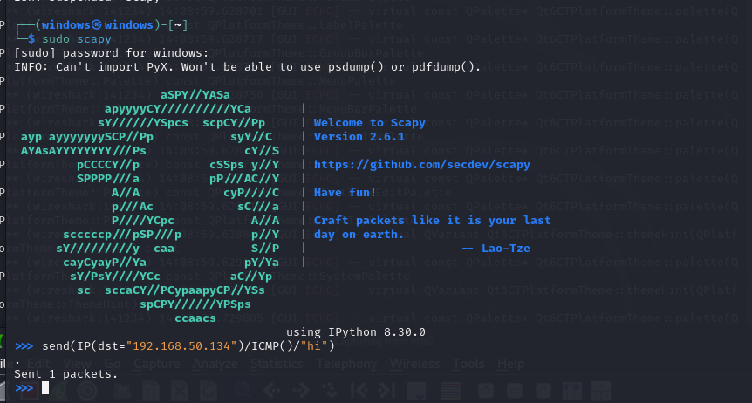

**after sniffing in WireShark.**

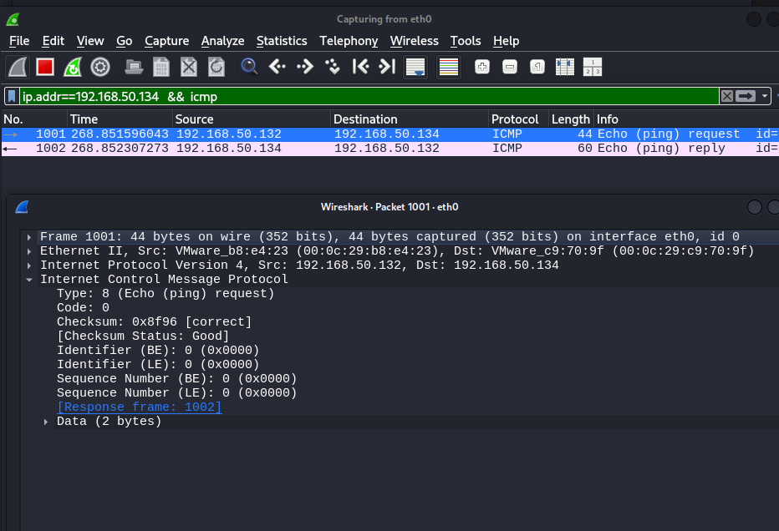

**· By adding source address in packet crafting (modifiying the source IP) I mean spoofing the source IP**

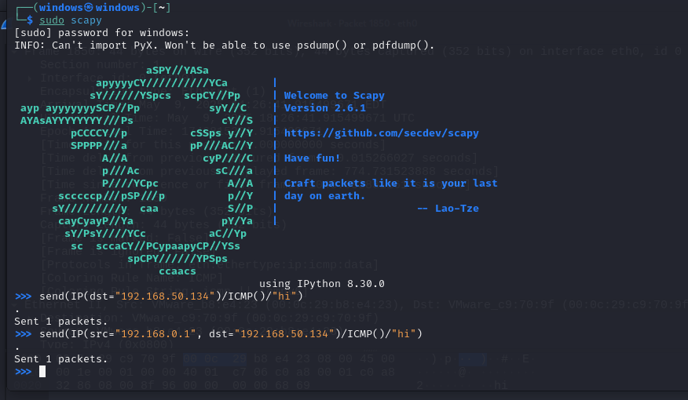

**Wireshark results:**

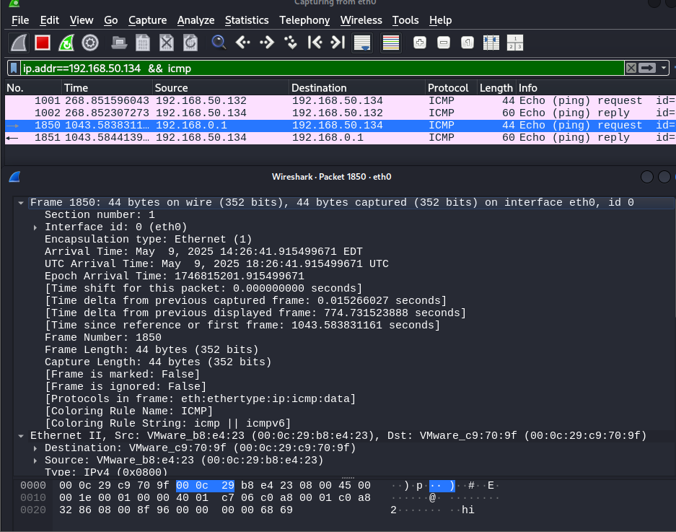

**Sending and receiving packets**

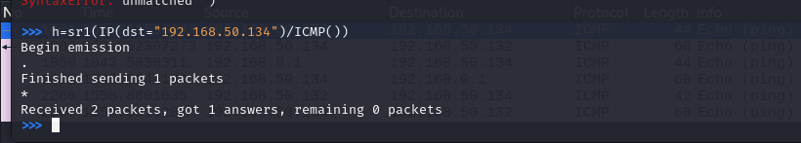

**Wireshark Results:**

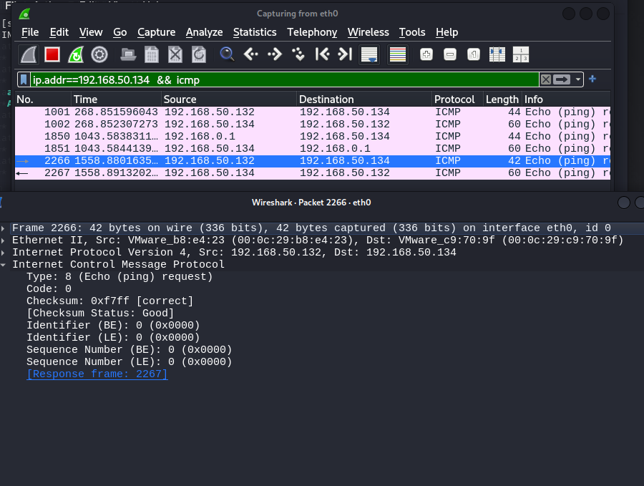

**Output : by putting the packet name.**

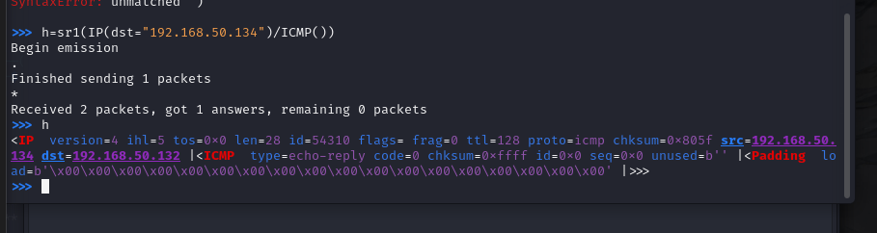

**Check output in different format**

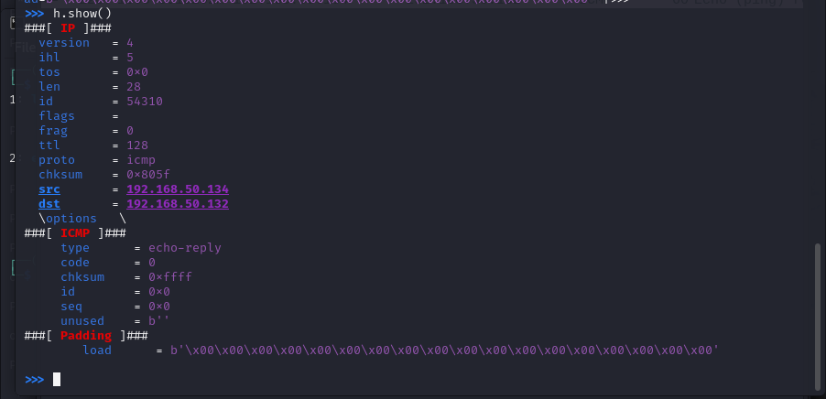

**To check “unanswered packets”, we use sr() function**

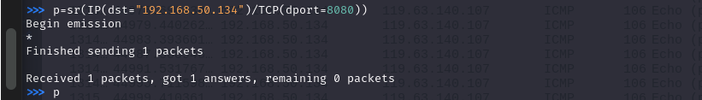

**Output:**

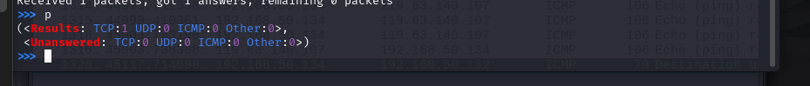

**Wireshark:**

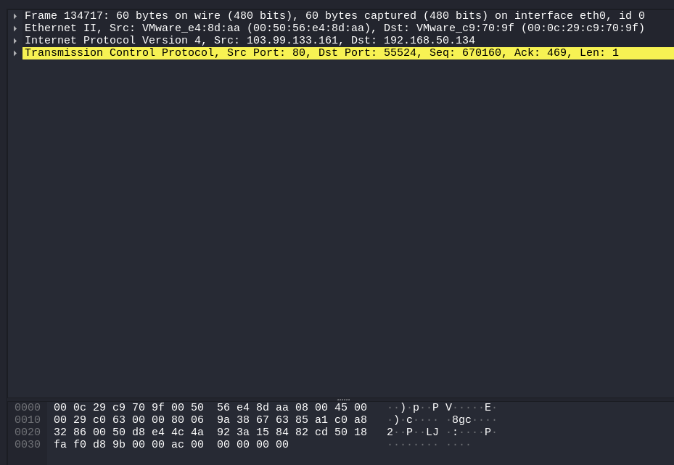

**Sending packets to multiple ports:**

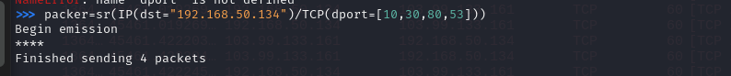

**Output:**



**Wireshark:**

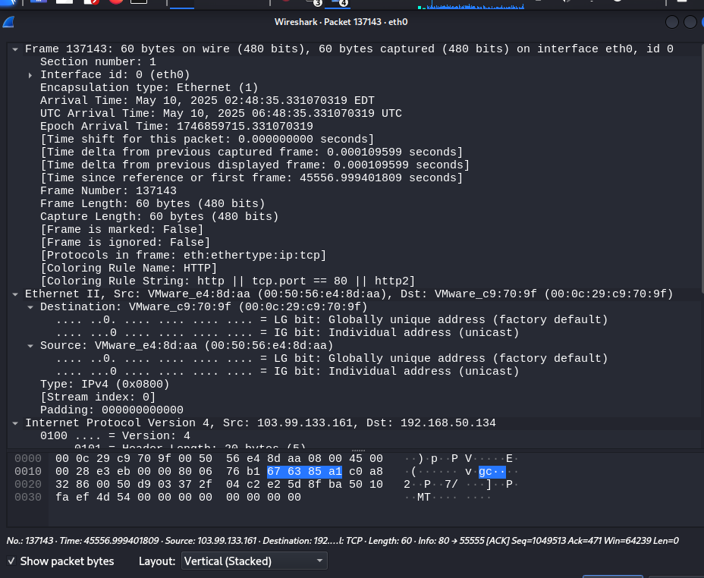

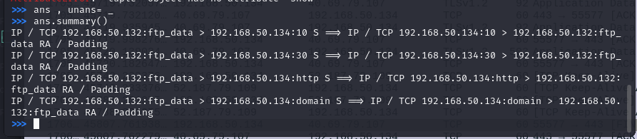

**Src Multiple ports :**

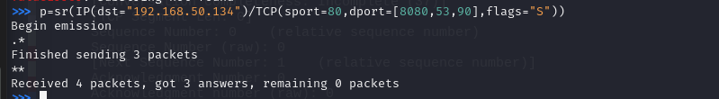

**Output:**

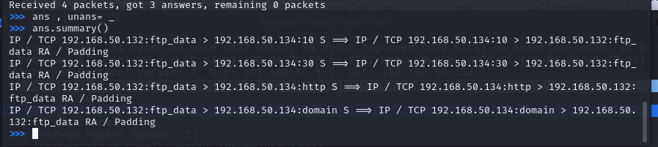

**Wireshark:**

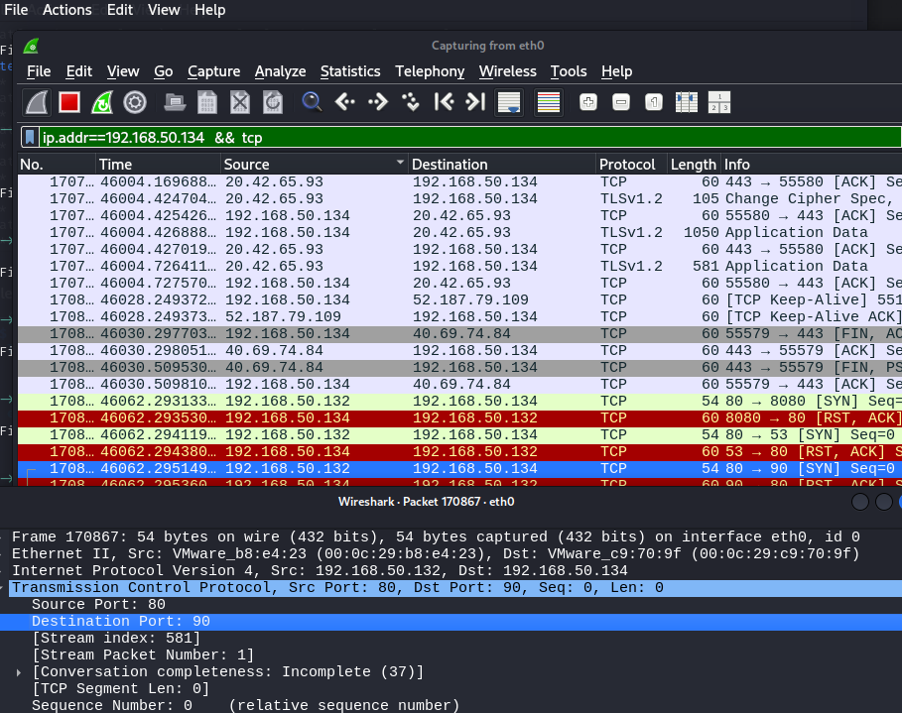

**Creating the Randshor():**

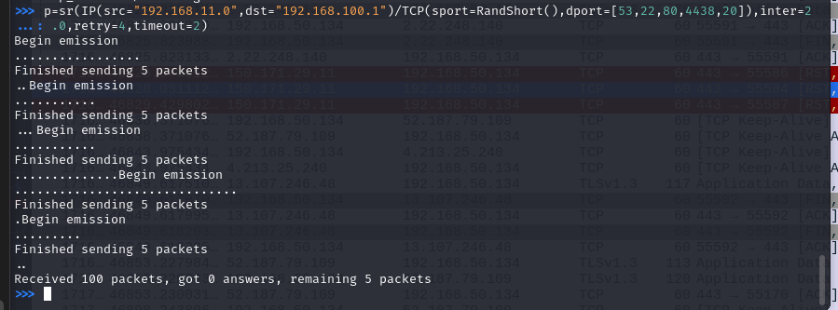

**Output:**

